1. Unzip the drivers package and copy drivers and “InstallDriver.cmd” to the system

Desktop

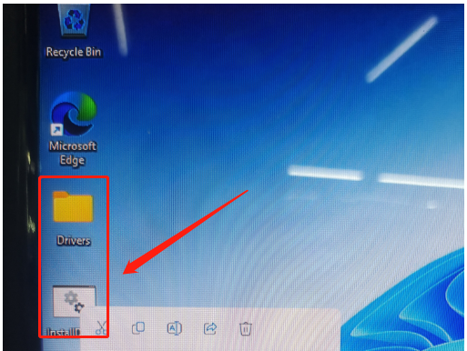

1. Unzip the driver package and copy the driver and “InstallDriver.cmd” to the system desktop

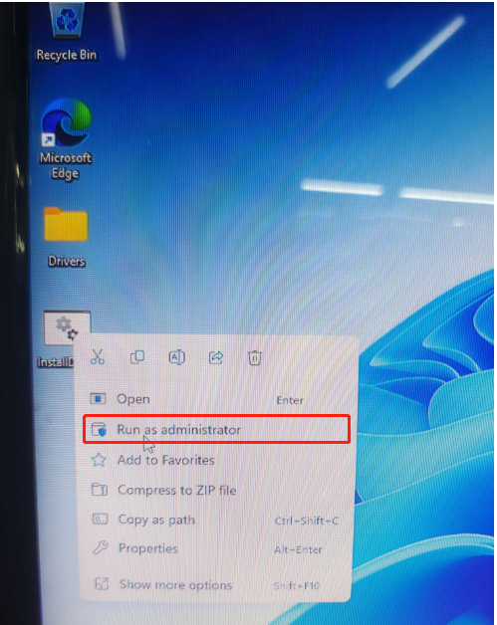

Remark.

1. The driver package name must be: Drivers, otherwise it will not be installed

2. Run “InstallDriver.cmd” to install the driver about 5-8 minutes

3. The driver will automatically reboot after installation is complete

4. Reboot to the device manager to check whether the driver has an exclamation point, if there is also an exclamation point driver is not installed in full, you need to repeat the administrator to run the rest of the driver installation.

5. This driver package is only the motherboard hardware driver package, if WIFI/BT is not read, please contact the corresponding WIFI/BT supplier to install the corresponding module driver